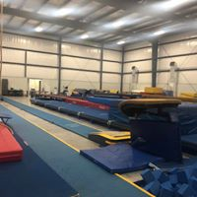

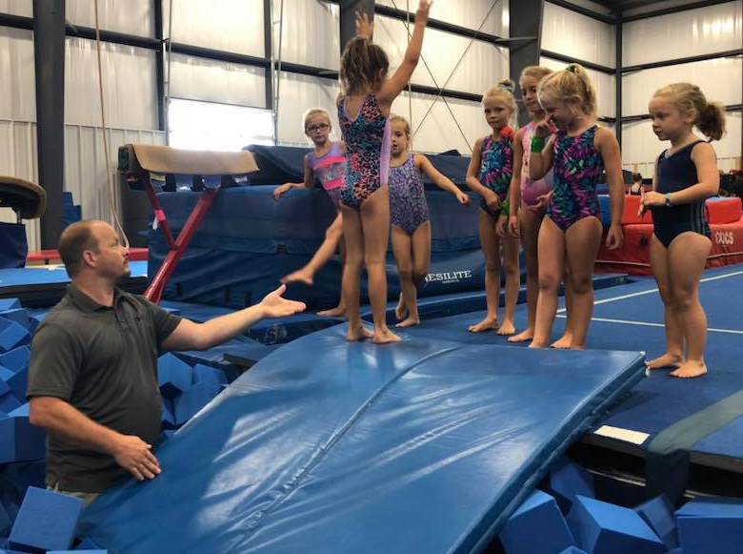
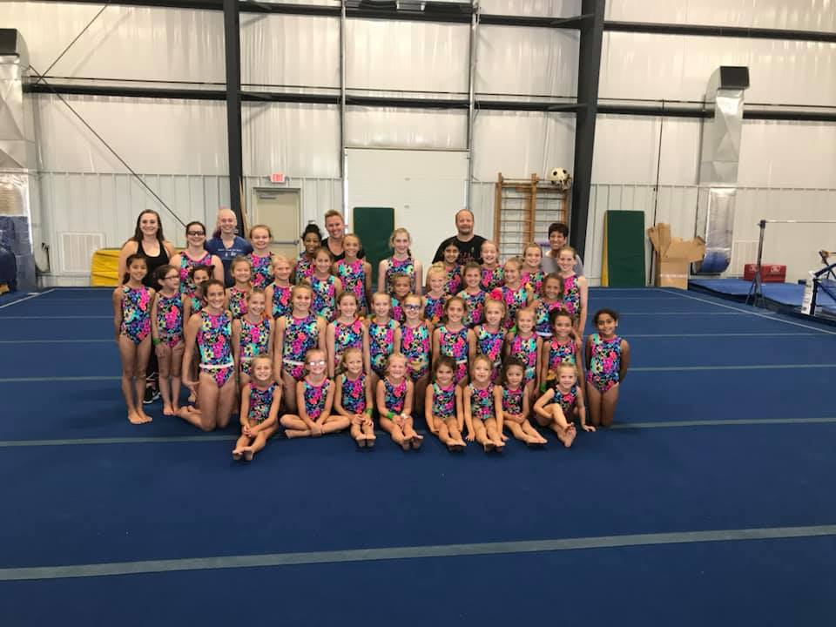
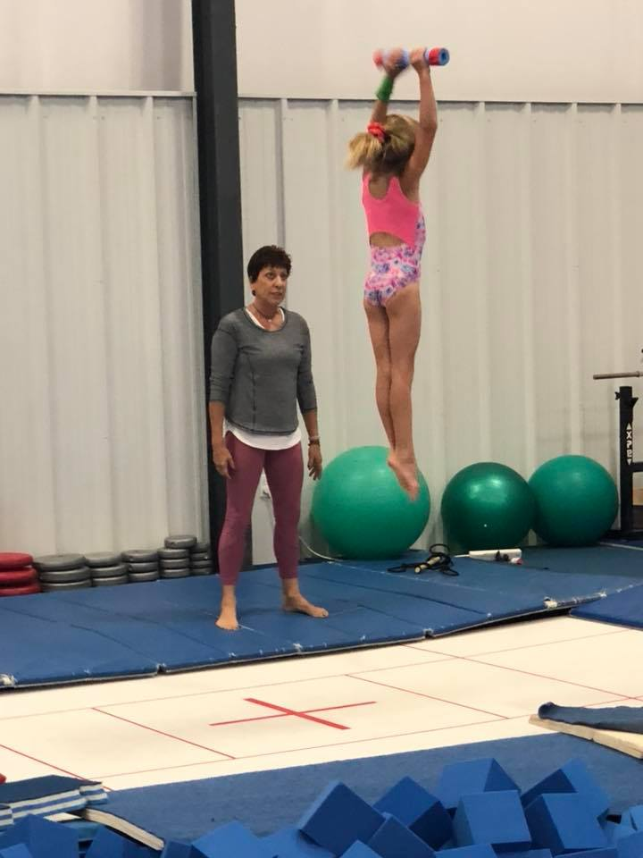
3320 Foxhill Road
Easton PA 18045
CO-OP Gymnastics Camp Registration Form
$100 Deposit Due May 1, 2019 , Balance due on June 17, 2019
Gymnast Name: _____________________________ Date of Birth: __________ Age: ___
Parent/Guardian :___________________________
Address: ____________________________________ Phone Number: _________________
----------------------------------------------------------- Email: _________________________
Current Training Level: ______________________
Emergency Contact: _________________________ Phone Number: __________________
Circle One: Full Day ($400) Half Day ($220) If half day: Leotard($75) Yes or No
Payment Info: __________________________ Email Questions to coopcoachkatelyn@gmaill.com

Sandra Greiner
Team Director

GIRLS CO-OP Team Coaches
Katelyn Christian
Dyanna Fauci
Rae Greiner
Lynn Perry
Guest Clinicians:
Tony Gehman
Alonzo Ruffin
Joy Umenhofer
Phillip Zak

2019

GIRLS CO-OP Competitive Team Camp

Levels 1-10, XCEL

Come work with GIRLS CO-OP Team Coaches and Guest Clinicians including:
  - June 24-28
Tentative Schedule

Monday, June 24
8:15 AM Gym Opens, Registration
8:45 AM Camp Welcome
9:00-12:30 Morning Training
12:30-1:00 Lunch
1:00-3:00 Afternoon Training
Tuesday, Wednesday June 25, 26
8:30 AM Gym Opens
9:00-12:30 Morning Training
12:30-1:00 Lunch
1:00-3:00 Afternoon Training
Half Day Campers may be picked up following lunch at 1 PM.

Thursday, June 27
8:30 AM Gym Opens
9:00-12:30 Morning Training
12:30-1:00 Lunch
1:00-3:00 Afternoon Training
5:00-7:00 Open Gym
Friday, June 28
8:30 AM Gym Opens
9:00-1:00 Morning Training
1:00 Camp Concludes
**Each gymnast should bring a water bottle, healthy lunch, and sneakers for outdoor running**

GIRLS CO-OP Gymnastics…

Where stars are born and champions are made!
We are excited to announce that 2019 Summer Camp will take place in our brand new gym. Come try out new skills with our clinicians in our state of the art pit!
Cost of full day camp includes:
- Daily training: Vault, Bars, Beam, Floor, Conditioning, Speed Training, Dance, Mental Training, Team Building, Trampoline
- An open gym session on Thursday evening for extra practice
- Camp themed leotard
*Leotard is an extra charge for ½ day campers*

Beam Pic

